PROJECT 1
Highly Scalable and Highly Available Web Application Deployment on Microsoft Azure Using Custom VM Image, Virtual Machine Scale Sets (VMSS), Virtual Network, and Load Balancer.
SUBMITTED BY
GEORGE DEVID JOHN THEKKINETH

Project Overview
This project focuses on designing and deploying a highly scalable, highly available, and production-ready web application architecture on Microsoft Azure. The solution leverages core Azure infrastructure services such as Virtual Networks, Virtual Machines, Custom VM Images, Virtual Machine Scale Sets (VMSS), and Azure Load Balancer.
The project demonstrates real-world cloud engineering practices used in enterprise-grade applications where uptime, scalability, and consistency are critical.

Project Objective
The primary objectives of this project are:
- To design a highly available web application architecture on Azure
- To implement horizontal scalability using Virtual Machine Scale Sets
- To ensure configuration consistency using a reusable Golden VM Image
- To distribute incoming traffic efficiently using an Azure Load Balancer
- To gain hands-on experience with Azure IaaS services and networking concepts
Business Use Case & Importance
Modern web applications must be resilient, scalable, and fault-tolerant. This project simulates a real-world scenario where:
- The application must remain available even if one or more servers fail
- Traffic load may increase unpredictably and must be handled automatically
- All server instances must maintain identical configurations
This architecture is commonly used in:
- E-commerce platforms
- Enterprise web applications
- SaaS products
- Public-facing APIs and websites

Architecture Overview

High-Level Architecture Description
- Users access the application via the internet
- Requests are routed through an Azure Standard Public Load Balancer
- The Load Balancer distributes traffic across multiple VM instances
- VM instances are part of a Virtual Machine Scale Set (VMSS)
- All resources are hosted inside a custom Azure Virtual Network

Architecture Diagram

Implementation Approach

Step 1: Resource Group Creation

A dedicated resource group was created to logically organize and manage all Azure resources related to the project.

Step 2: Custom Virtual Network Setup

A custom Virtual Network with address space 10.20.0.0/16 was created along with a subnet snet-web (10.20.1.0/24) to host the web servers.
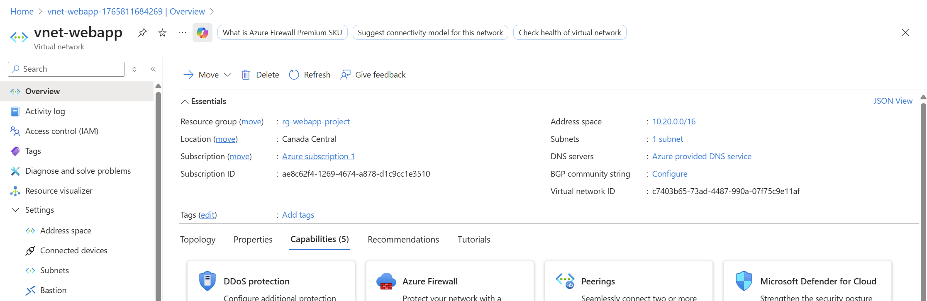

Step 3: Golden Virtual Machine Deployment

An Ubuntu Server 22.04 VM was deployed to act as the base (Golden VM) for the application.
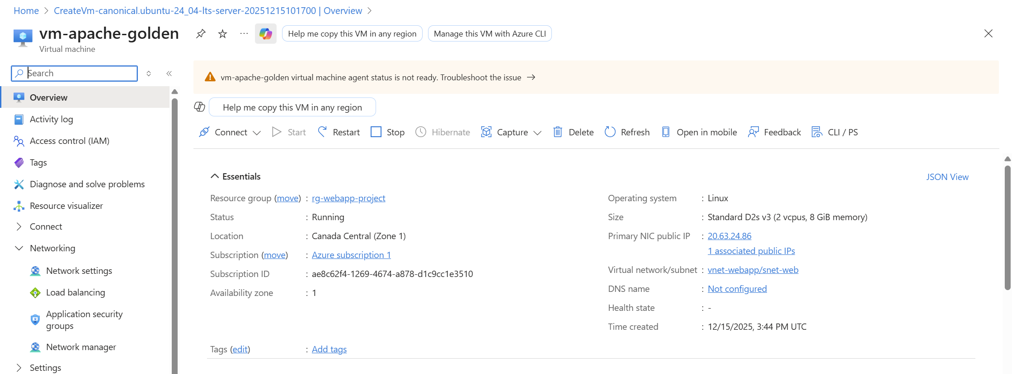

Step 4: Web Server Installation

Apache Web Server was installed and configured. A sample web page displaying the hostname was deployed to verify load balancing.
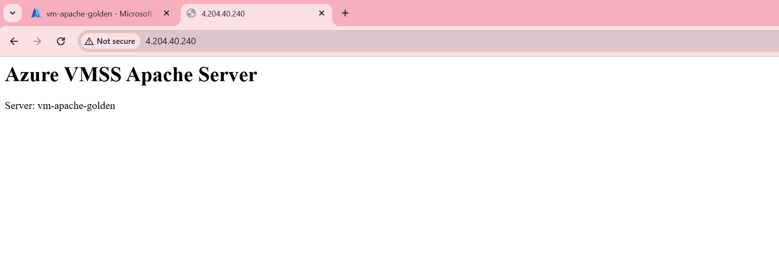

Step 5: VM Deprovisioning

The VM was stopped and deallocated to prepare it for image capture.

Step 6: Custom VM Image Creation

A reusable VM image was captured containing:

Operating System

Apache Web Server

Application configuration

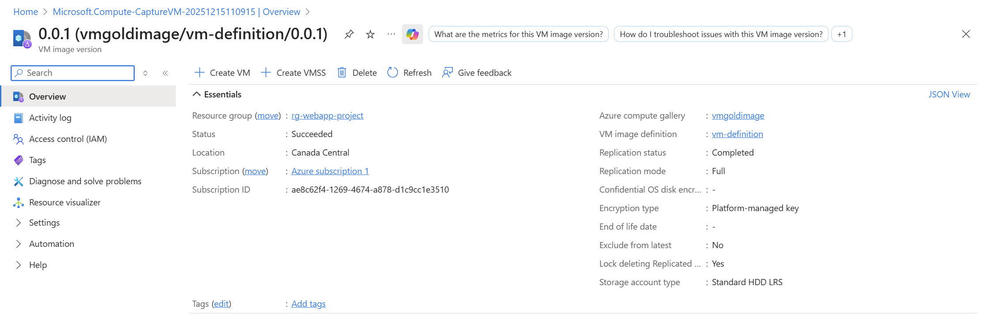
Step 7: Azure Load Balancer Configuration

A Standard Public Load Balancer was created with:

Backend Pool

Health Probe (Port 80)

Load Balancing Rule (80 → 80)

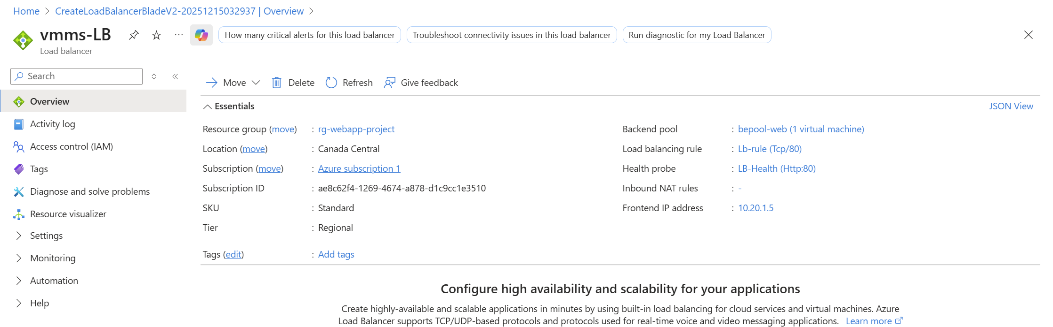
Step 8: Virtual Machine Scale Set Deployment

A VMSS was created using the custom image and attached to the load balancer backend pool. Initial instance count was set to two.
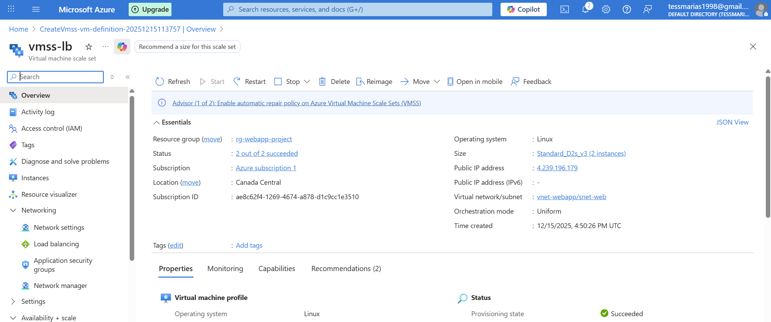
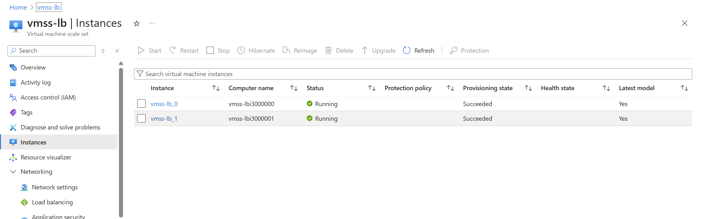

Step 9: Deployment Validation

The Load Balancer public IP was accessed via a browser. Refreshing the page showed different hostnames, confirming successful load balancing.

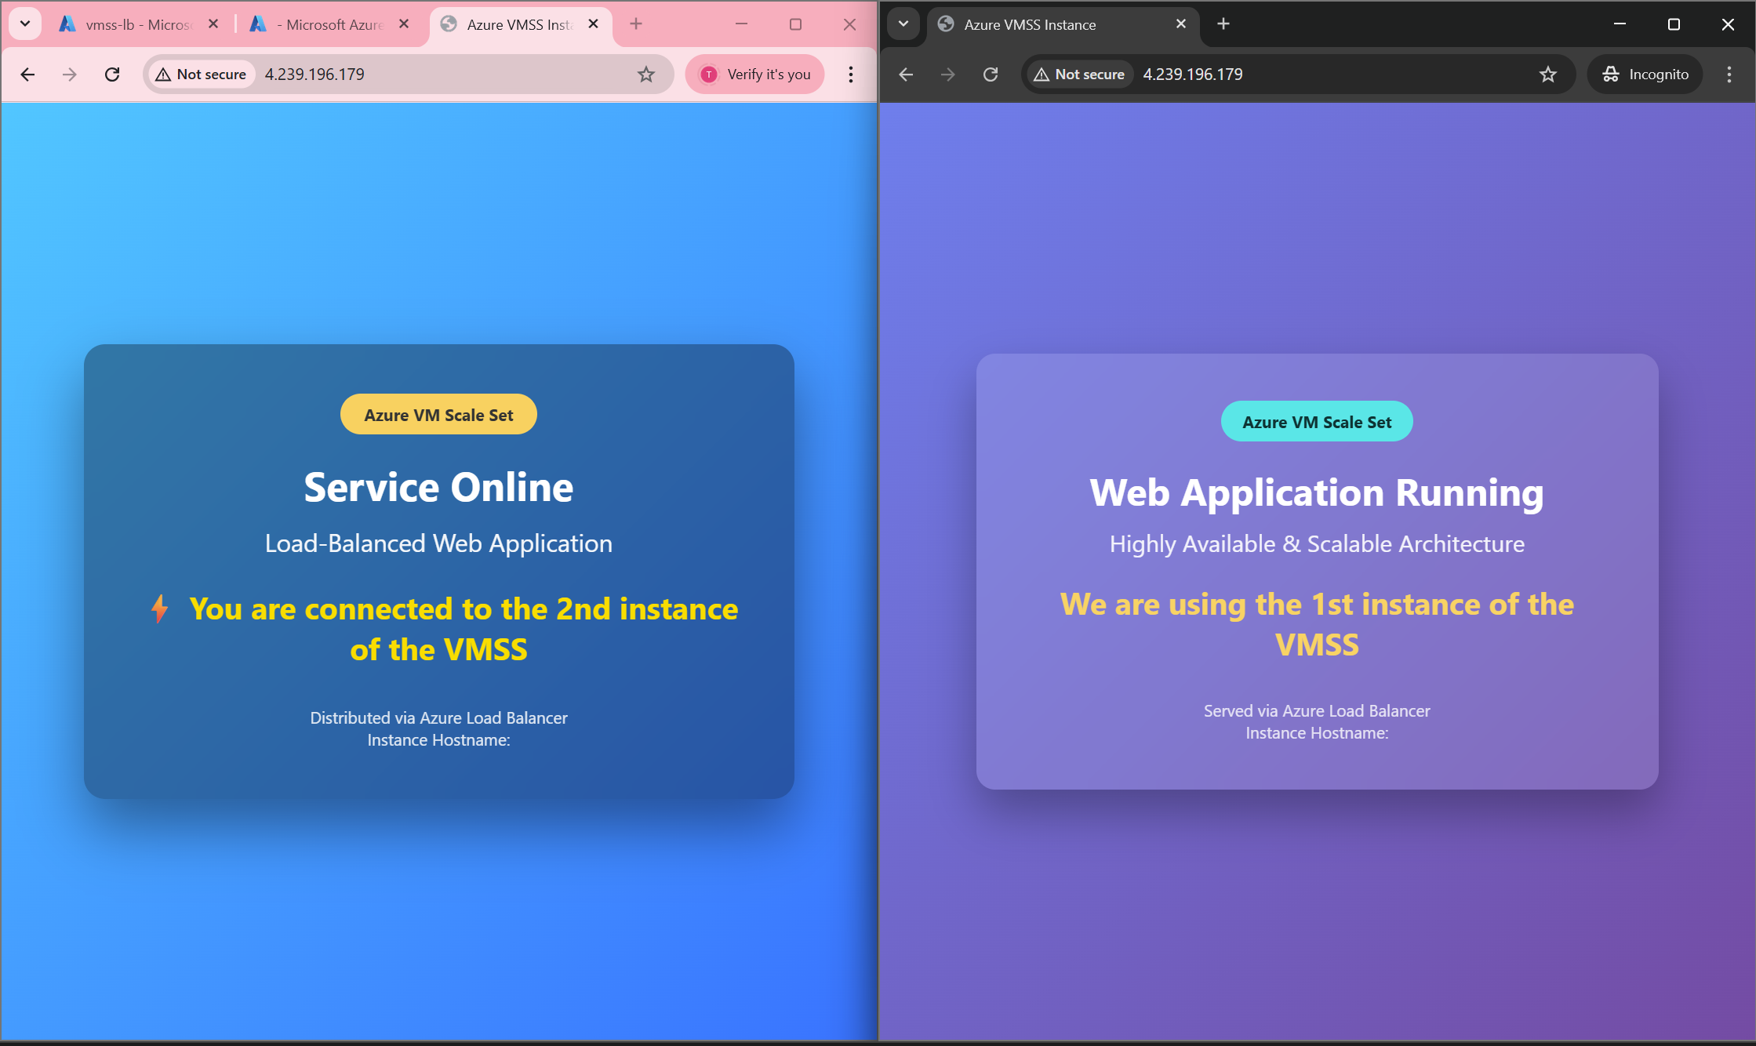
Key Features Implemented

High Availability through multiple VM instances

Horizontal scalability using VMSS

Centralized traffic distribution with Load Balancer

Network isolation using custom VNet and subnet

Configuration consistency via custom VM image

Technical Skills Obtained

Microsoft Azure Infrastructure (IaaS)

Virtual Networking (VNet, Subnets)

Linux Server Administration (Ubuntu)

Apache Web Server Configuration

Virtual Machine Imaging

Virtual Machine Scale Sets (VMSS)

Azure Load Balancer Configuration

High Availability & Scalability Design

Cloud Architecture Fundamentals

Key Takeaways

Load Balancers are critical for fault tolerance and traffic distribution

VMSS enables elastic scaling with minimal manual intervention

Custom images ensure configuration consistency across environments

Proper resource sequencing simplifies deployment

Azure IaaS services provide strong foundations for enterprise applications

Conclusion
This project successfully demonstrates the design and deployment of a highly available and scalable web application using Microsoft Azure. The implementation follows industry best practices and closely mirrors real-world cloud architectures used in production environments. The project provides strong foundational experience for roles such as Cloud Engineer, DevOps Engineer, and Azure Solution Architect.

